Stakeholder Advisory Council
Minutes
November 24th, 2020
Video recording of the meeting: https://www.youtube.com/watch?v=sCuKCAR5wPc&feature=youtu.be
In attendance: Carole White, Sara Masoud, Debbie James, Ashlie Glassner, James Butler, Byron Cordes, Cesar Alvarado, Ginny Funk, Bill Zinsmeyer, Janet Zinsmeyer, Mayra Mendoza
- COVID-19 Enhancement
  - Project update – share survey with your networks
  - Sara will send you the link to share
Carole and Sara updated the SAC on the progress of the COVID-19 survey.
With SAC feedback and review, the final version of the survey has been completed and distributed to the council. SAC members should forward the survey on to their networks with a minimum goal to reach 15-20 respondents.
The survey will primarily be distributed using an online link (below) but the option to do a printed version with team support is available, particularly for individuals living with dementia who may prefer this option.
At the end of the survey, respondents will be invited to complete an additional survey if they would
1) like to receive a $20 gift card in appreciation of their efforts to complete the survey and
2) if they are interested in participating in a focus group about the impact of covid-19 on dementia care.
COVID-19 SURVEY LINK: https://redcap.link/xaby35dc
Collection for the survey is planned to end by January 31, 2021 and focus groups will begin in December 2020.
- February Symposium
  - Theme, speakers, SAC panel
The council was consulted for input on the February symposium. Speakers will be those who were originally going to speak at the in-person symposiums pre-COVID.
This will likely include Katie Brandt (pictured below). She is the Director of Caregiver Support Services and Public Relations for the Frontotemporal Disorders Unit at Mass General Hospital – also a 2x care partner for her husband who had Frontotemporal dementia and father who had Alzheimer’s dementia. Her website is here: https://loveisoutthereftd.org/
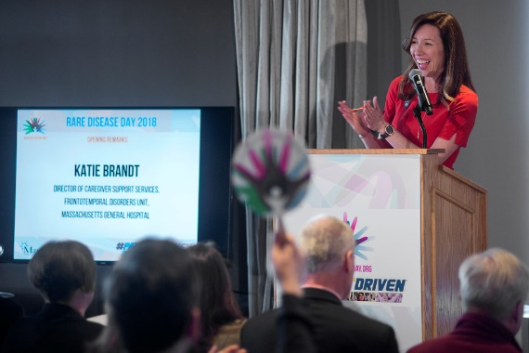
A panel of SAC members will also speak at the symposium, presenting about the COVID-19 enhancement project.
- SAC Interview paper
  - Sara and Ashlie will share findings
Sara and Ashlie presented findings from the evaluation of engagement with the SAC. Members were invited to share insight and whether they felt the findings accurately represented their experiences and perspectives. The findings have been drafted into a publication to be submitted to a journal in early December.

- Group updates

The Alzheimer’s Association has released talking points to address the recent recommendation by the FDA’s drug advisory committee to reject approval of the Biogen drug, Aducanumab. The talking points emphasize the Alzheimer’s Association’s stance that approval should be granted for the long-awaited drug. Talking Points have been shared with the committee via email.
FDA Committee Announcement: https://www.fda.gov/advisory-committees/advisory-committee-calendar/november-6-2020-meeting-peripheral-and-central-nervous-system-drugs-advisory-committee-meeting#event-information
Committee members: https://www.fda.gov/advisory-committees/peripheral-and-central-nervous-system-drugs-advisory-committee/peripheral-and-central-nervous-system-drugs-advisory-committee-roster

- Next meeting: January 26th 2021, 12-1pm

The December meeting is cancelled due to the holiday break. The project team will communicate updates via email as needed until the next meeting in January where we will update on the COVID-19 project and finalize plans for the February symposium.
