Stakeholder Advisory Council
Minutes
January 26th, 2021
Link to recording: https://youtu.be/fnScwDaVW3o
In attendance:

Carole White
Sara Masoud
Byron Cordes
Ashlie Glassner
Cesar Alvarado
Michael Foster
Kiki Foster
Bill Zinsmeyer
Janet Zinsmeyer
Neela Patel
Mayra Mendoza
Debbie James
Sheran Rivette

- COVID-19 Enhancement
  - Focus groups (See notes below)
  - Preliminary results Reviewed numbers of submitted surveys and scheduled groups.
- Annual Symposium – March 16th 10am-1pm
The SAC reviewed the agenda for the symposium and were encouraged to register themselves and members of their community networks. The COVID-19 project will be the focus of the symposium. The title is “Dementia Care in the Context of the COVID-19 Pandemic: The Impacts for Families”.
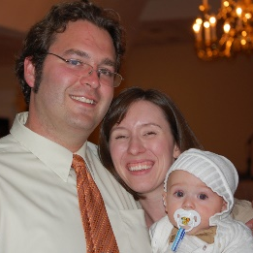
Katie Brandt: Advocate, a caregiver, and a parent. Was caregiver for her husband who was diagnosed with Frontotemporal Degeneration at age 29. Four days after her husband was diagnosed, her mother died, followed only 17 days later by her father’s diagnosis of early onset Alzheimer’s disease at age 59. Since her husband’s passing, Katie became co-chair for the National Alzheimer’s Project Act (NAPA) Advisory Council and now serves as the Director of Caregiver Support Services and Public Relations for the Frontotemporal Disorders Unit at Mass General Hospital.
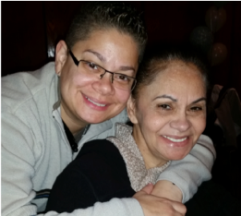
Daisy Duarte: Daisy is a caregiver, clinical trial participant and advocate for the LatinosAgainstAlzheimer’s Network. She has been a caregiver for her mother, Sonia, who was diagnosed with early onset Alzheimer’s in 2013 at age 55. In 2014, Daisy tested positive for the gene linked to early onset Alzheimer’s disease. As one of the few Latinas enrolled in an Alzheimer’s clinical trial, Daisy is committed to raising awareness of the importance of Alzheimer’s research and funding.
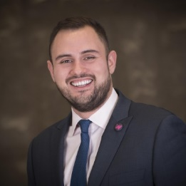
Jason Resendez: Jason is the Executive Director of the UsAgainstAlzheimer’s Center for Brain Health Equity and head of the LatinosAgainstAlzheimer’s Coalition. From clinical trial inclusion to paid family leave for dementia caregivers, he champions brain health equity at every level of the healthcare system.
SAC panel: Similar to the last symposium, we will also have a panel session with SAC members discussing findings from the COVID-19 enhancement project.

- Project Timeline review:
  - Caregiver focus groups are scheduled
  - Coming up: Persons living with dementia groups / individual interviews and health/social care professions (community and institution)
The SAC discussed the Enhancement timeline and upcoming activities. Nine focus groups are arranged, the first group is this week on the 28th with family caregivers of community dwelling individuals living with dementia (non-institutions).
Members of the SAC have covered focus group methods and a member of the SAC will accompany Carole, Sara, Ashlie, and/or Shanae in conducting these focus groups.
The sessions will be recorded, transcribed, anonymized, and analyzed for themes before the end of April 2021.
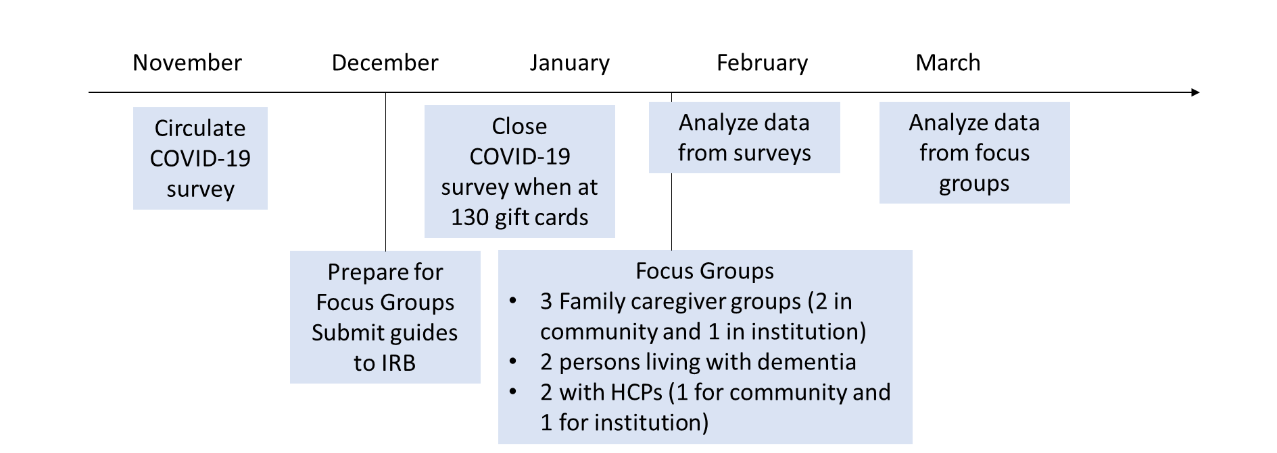

- Group updates?
UT Health is vaccinating community members – contact UT Health vaccine hotline for more information. They are distributing vaccines in bulk groups so improve herd immunity.
1,500 patients at Dr. Patel’s practice have already been vaccinated. Family caregivers are also getting the vaccine even if they are not UT patients. They will be registered as UT patients and given the vaccine if they are primary caregivers.
For people who don’t have primary care clinics like UT, they have to try to get appointments with the city or with WellMed though waitlists are long.
Sara and Carole will send updated vaccine information to the SAC after the meeting along with links to the resources discussed and the symposium registration link with the flyer.
- Next meeting: February 23rd, 2021, 12-1pm Confirmed by SAC

