PCORI Stakeholder Advisory Council
Minutes
February 23rd, 2021
Recording link: https://youtu.be/P8BRyOXXIig
In attendance:

Carole White
Ashlie Glassner
Sara Masoud
James Butler
Byron Cordes
Bill Zinsmeyer
Janet Zinsmeyer
Ginny Funk
Debbie James
Mayra Mendoza

- COVID-19 Enhancement
  - Update on the focus groups & surveys
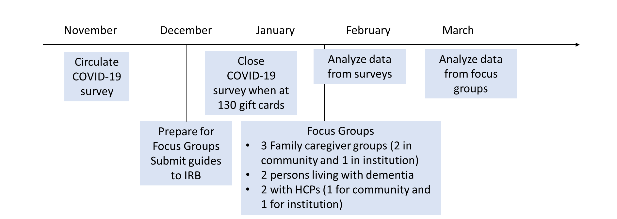
  - Project Timeline:

Most of the focus groups have been completed by this point. We had some delay from issues with the Winter Storm in Texas.
The SAC discussed the priorities project, we collected over 180 completed responses. 120 caregiver, 20+ PLWD, and the rest are health and social care professionals/students/researchers. The priorities that were consistent across the groups was the importance of the time around diagnosis. This isn’t surprising since we have seen this in the discussion over the last few years of the project. Particularly the importance of connecting to resources at the time of the diagnosis, how the diagnosis is delivered, and how physicians inform patients about resources available to them.
The group talked a lot of the importance of a Dementia Friendly community to promote this level of support for families living with dementia. Byron: how do we help families get connected to available resources like the Biggs Institute, or address gaps in resources. We need to cultivate a culture that addresses the stigma of Alzheimer’s and educate health and social providers to understand what that diagnosis means beyond the symptoms. What does it mean for a person’s life and connection in their communities??

- Annual Symposium – March 16th 10am-1pm
  - Please register if you haven’t already: https://dementiacovid19.eventbrite.com
  - Share the flyer and send invitations via email, text, social media.
Important updates about the symposium – we have met with every speaker to walk through their presentations. Based on recommendations from the SAC we reached out to the Office of Governmental Affairs to schedule politicians to speak and listen to the symposium to emphasize the importance of involvement from our political leaders. We were able to schedule Councilman Manny Pelaez of District 8, San Antonio to speak at the end of the symposium. We were also able to confirm State Senator Menendez to speak at the opening of the symposium about the importance of state-level policy to support families living with dementia.
- Manuscripts
  - Priorities paper to be submitted first week of March - We will submit the priorities paper to the Journal The Patient - Patient-Centered Outcomes Research.
  - SAC Engagement paper to be submitted end of February – To be submitted to Research Involvement and Engagement.
More updates about manuscripts to come as they are reviewed and revised.
- Group updates
  - Group photo – the SAC members in attendance took a group photo over Zoom for the symposium.

- Next meeting: March 23rd , 2020, 12-1pm Confirmed with the SAC

